STOCK ANALYSIS REPORT
Finance & Investment Analysis Internship
CodeAlpha
Task 1 – Stock Analysis Report
Prepared by: Mahek Dhingra
Programme: MBA Finance
Stocks Selected
Reliance Industries Limited
Tata Consultancy Services Limited (TCS)
HDFC Bank Limited
Date: August 2026

1. Introduction
Stock analysis evaluates a company's market performance, valuation, financial performance and business prospects. This report analyzes Reliance Industries Limited, Tata Consultancy Services (TCS), and HDFC Bank Limited, representing diversified, information-technology and banking sectors respectively.

2. Objectives
• Analyze price trends.
• Compare P/E ratios and market capitalization.
• Examine selected performance indicators.
• Review recent news and developments.
• Compare the strengths and risks of the three stocks.

3. Methodology
The study uses publicly available market information, company financial results and recent financial-market news. Market figures are reference indicators because stock prices and valuation measures change continuously. The latest trading-price reference used is 14 August 2026.

4. Reliance Industries Limited
Reliance Industries is a diversified Indian company with businesses across energy, oil-to-chemicals, digital services, telecommunications and retail.
Indicator | Value
Market Capitalization | ₹17,81,558.72 crore
P/E Ratio | 18.66
52-Week High | ₹1,611.20
52-Week Low | ₹1,253.20
Price – 14 Aug 2026 | ₹1,308.00
The stock closed at ₹1,308 on 14 August 2026, about 18.82% below its 52-week high. Reliance reported Q1 FY27 gross revenue of ₹3,40,257 crore, EBITDA of ₹54,067 crore and profit after tax of ₹23,196 crore. Recent market attention included its Q1 results and an MSCI index-weight reduction that contributed to selling pressure.

5. Tata Consultancy Services Limited
TCS is a leading Indian IT-services company providing consulting, technology and digital-transformation solutions globally.
Indicator | Value
Market Capitalization | ₹7,49,269.74 crore
P/E Ratio | 14.50
52-Week High | ₹3,336.70
52-Week Low | ₹1,976.80
Price – 14 Aug 2026 | ₹2,359.00
TCS closed at ₹2,359 on 14 August 2026, about 29.30% below its 52-week high. Q1 FY27 revenue was ₹72,275 crore, net income ₹13,849 crore and operating margin 24.0%. Annualized AI revenue reached US$2.6 billion and the company announced an US$800 million AI-led transformation deal with SKF.

6. HDFC Bank Limited
HDFC Bank is one of India's leading private-sector banks, providing retail, wholesale and other financial services.
Indicator | Value
Market Capitalization | ₹12,75,229.92 crore
P/E Ratio | 15.87
52-Week High | ₹1,020.35
52-Week Low | ₹726.65
Price – 14 Aug 2026 | ₹727.35
HDFC Bank closed at ₹727.35 on 14 August 2026, around 28.72% below its 52-week high. In Q1 FY27, standalone net profit rose 5% year-on-year to ₹19,060 crore, net interest income increased 6.7% to ₹33,535 crore, gross advances grew 15.4% to ₹30.61 lakh crore and deposits increased 14.7% to ₹31.71 lakh crore. Recent concerns include margin/valuation pressure and a small rise in gross NPAs to 1.17%.

7. Comparative Analysis
Indicator | Reliance | TCS | HDFC Bank
Market Cap (₹ crore) | 17,81,558.72 | 7,49,269.74 | 12,75,229.92
P/E Ratio | 18.66 | 14.50 | 15.87
52W High (₹) | 1,611.20 | 3,336.70 | 1,020.35
52W Low (₹) | 1,253.20 | 1,976.80 | 726.65
14 Aug Price (₹) | 1,308.00 | 2,359.00 | 727.35
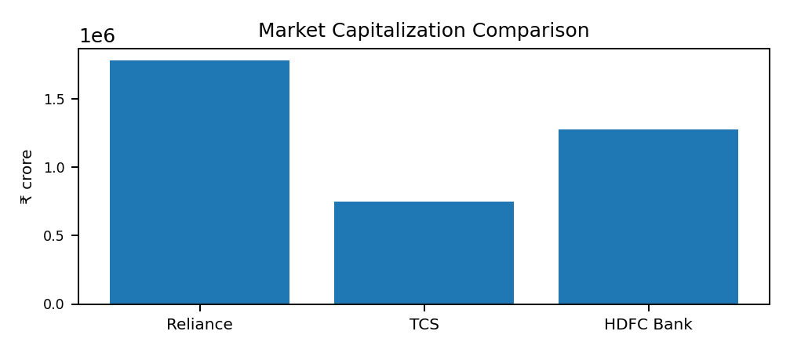 | 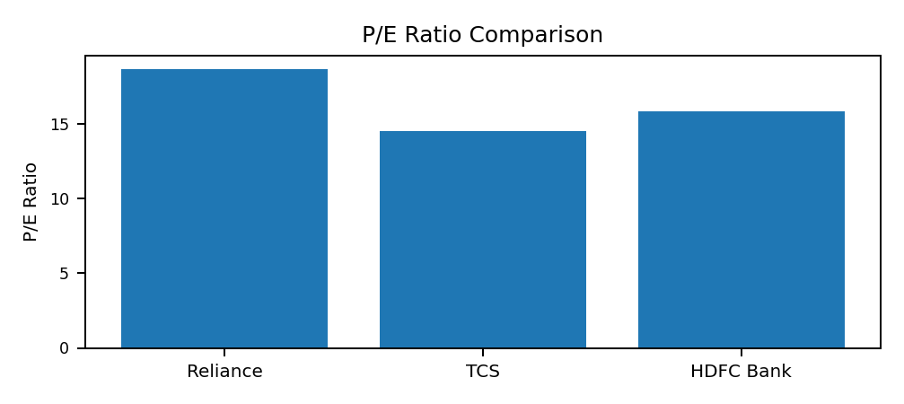

8. Key Findings and Conclusion
Reliance has the highest market capitalization in the selected dataset and benefits from a diversified business model. TCS has the lowest P/E ratio and strong exposure to AI and digital transformation. HDFC Bank provides exposure to India's banking cycle and continues to show growth in loans, deposits and profit, although asset quality and market sentiment require monitoring.
The analysis shows that investment decisions should not rely on a single measure. Market capitalization indicates company size, P/E provides a valuation perspective, price trends show market performance, and financial results and recent developments provide context about the underlying business. The three stocks have different growth drivers and risks, so diversification and individual risk assessment are important. This report is for academic/internship purposes and is not personalized financial advice.

9. References
• National Stock Exchange of India – equity market information for the selected companies.
• Reliance Industries – Financial Reporting, Q1 FY2027.
• Tata Consultancy Services – Q1 FY2027 Financial Results, 9 July 2026.
• HDFC Bank – Q1 FY2027 Financial Results, 18 July 2026.
• MarketWatch – 14 August 2026 closing-price reports for Reliance Industries, TCS and HDFC Bank.
• Reuters – Indian market and HDFC Bank reporting, August 2026.

